**Exercise 1: Configuring a Basic Spring Application**

**Scenario:**

Your company is developing a web application for managing a library. You need to use the Spring Framework to handle the backend operations.

**pom.xml**

<project xmlns="http://maven.apache.org/POM/4.0.0"

xmlns:xsi="http://www.w3.org/2001/XMLSchema-instance"

xsi:schemaLocation="http://maven.apache.org/POM/4.0.0

http://maven.apache.org/xsd/maven-4.0.0.xsd">

<modelVersion>4.0.0</modelVersion>

<groupId>com.library</groupId>

<artifactId>LibraryManagement</artifactId>

<version>1.0-SNAPSHOT</version>

<packaging>jar</packaging>

<name>LibraryManagement</name>

<description>Simple Spring XML project for managing a library</description>

<properties>

<maven.compiler.source>1.8</maven.compiler.source>

<maven.compiler.target>1.8</maven.compiler.target>

<project.build.sourceEncoding>UTF-8</project.build.sourceEncoding>

</properties>

<dependencies>

<!-- Spring Core Context Dependency -->

<dependency>

<groupId>org.springframework</groupId>

<artifactId>spring-context</artifactId>

<version>5.3.34</version>

</dependency>

</dependencies>

<build>

<resources>

<resource>

<directory>src/main/resources</directory>

</resource>

</resources>

</build>

</project>

**MainApp.java**

package com.library;

import com.library.service.BookService;

import org.springframework.context.ApplicationContext;

import org.springframework.context.support.ClassPathXmlApplicationContext;

public class MainApp {

public static void main(String[] args) {

ApplicationContext context = new ClassPathXmlApplicationContext("applicationContext.xml");

BookService bookService = context.getBean("bookService", BookService.class);

bookService.listBooks();

}

}

**BookService.java**

package com.library.service;

import com.library.repository.BookRepository;

public class BookService {

private BookRepository bookRepository;

public void setBookRepository(BookRepository bookRepository) {

this.bookRepository = bookRepository;

}

public void listBooks() {

System.out.println("Inside BookService.listBooks()");

bookRepository.fetchBooks();

}

}

**BookRepository.java**

package com.library.repository;

public class BookRepository {

public void fetchBooks() {

System.out.println("Fetching list of books from the repository...");

}

}

**applicationContext.xml**

<?xml version="1.0" encoding="UTF-8"?>

<beans xmlns="http://www.springframework.org/schema/beans"

xmlns:xsi="http://www.w3.org/2001/XMLSchema-instance"

xsi:schemaLocation="

http://www.springframework.org/schema/beans

http://www.springframework.org/schema/beans/spring-beans.xsd">

<bean id="bookRepository" class="com.library.repository.BookRepository"/>

<bean id="bookService" class="com.library.service.BookService">

<property name="bookRepository" ref="bookRepository"/>

</bean>

</beans>

OUTPUT

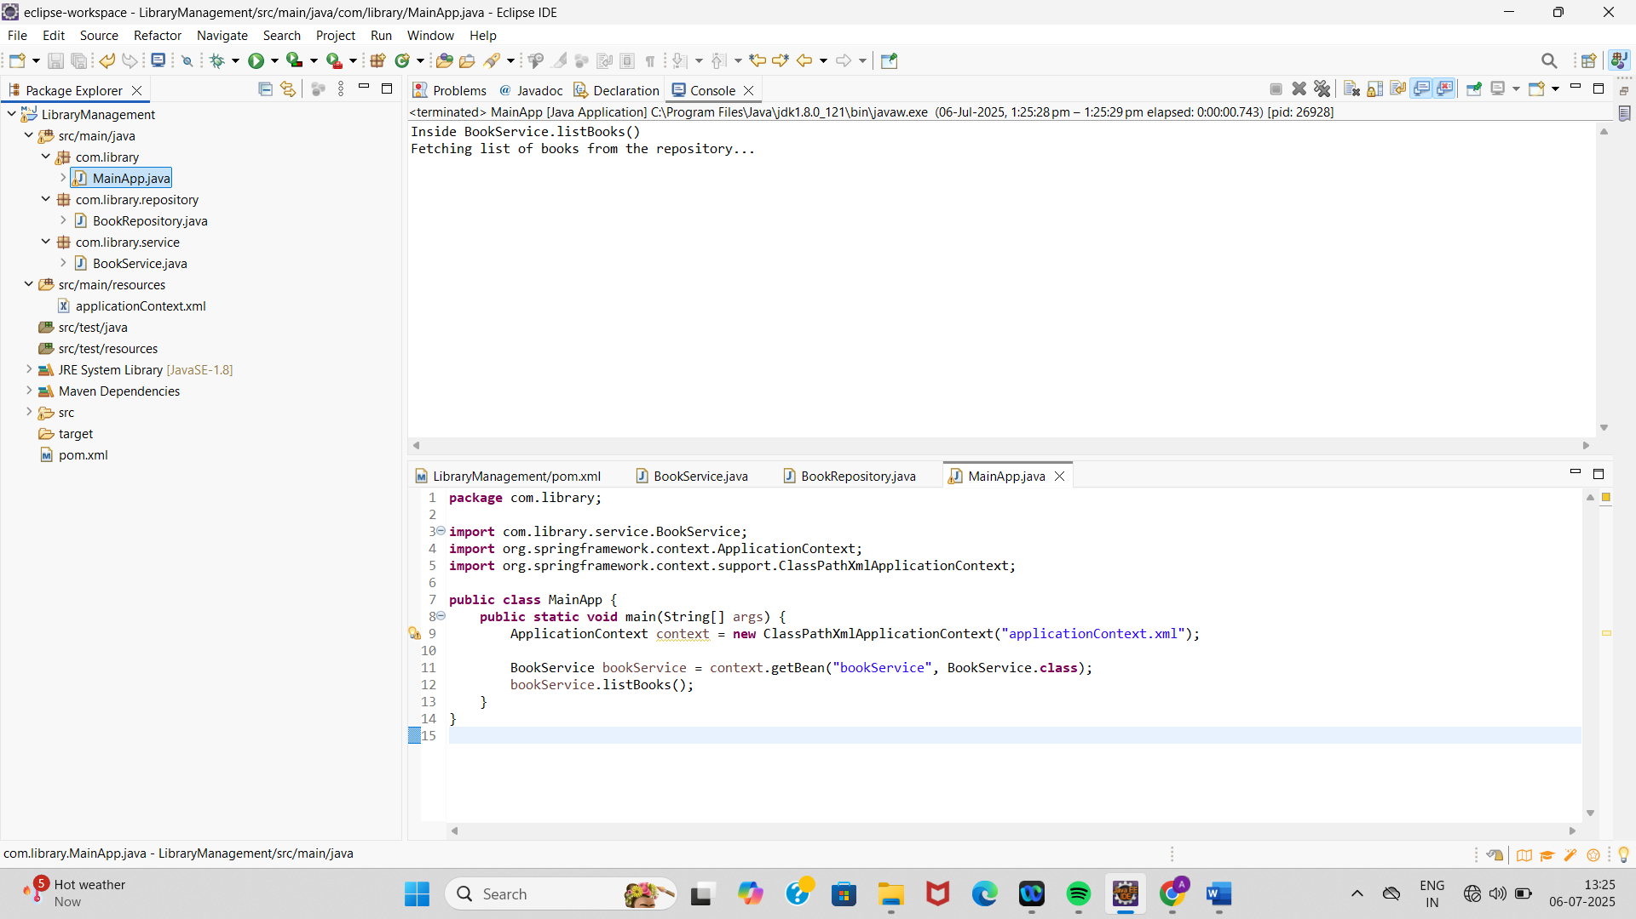

**Exercise 2: Implementing Dependency Injection**

**Scenario:**

In the library management application, you need to manage the dependencies between the BookService and BookRepository classes using Spring's IoC and DI.

applicationContext.xml

<?xml version="1.0" encoding="UTF-8"?>

<beans xmlns="http://www.springframework.org/schema/beans"

xmlns:xsi="http://www.w3.org/2001/XMLSchema-instance"

xsi:schemaLocation="

http://www.springframework.org/schema/beans

http://www.springframework.org/schema/beans/spring-beans.xsd">

<!-- Repository Bean -->

<bean id="bookRepository" class="com.library.repository.BookRepository"/>

<!-- Service Bean with DI via setter -->

<bean id="bookService" class="com.library.service.BookService">

<property name="bookRepository" ref="bookRepository"/>

</bean>

</beans>

BookService.java

package com.library.service;

import com.library.repository.BookRepository;

public class BookService {

private BookRepository bookRepository;

// Setter method for DI

public void setBookRepository(BookRepository bookRepository) {

this.bookRepository = bookRepository;

}

public void listBooks() {

System.out.println("Inside BookService.listBooks()");

bookRepository.fetchBooks();

}

}

MainApp.java

package com.library;

import com.library.service.BookService;

import org.springframework.context.ApplicationContext;

import org.springframework.context.support.ClassPathXmlApplicationContext;

public class MainApp {

public static void main(String[] args) {

// Load Spring configuration

ApplicationContext context = new ClassPathXmlApplicationContext("applicationContext.xml");

// Get BookService bean with BookRepository injected

BookService bookService = context.getBean("bookService", BookService.class);

bookService.listBooks(); // test it

}

}

OUTPUT:

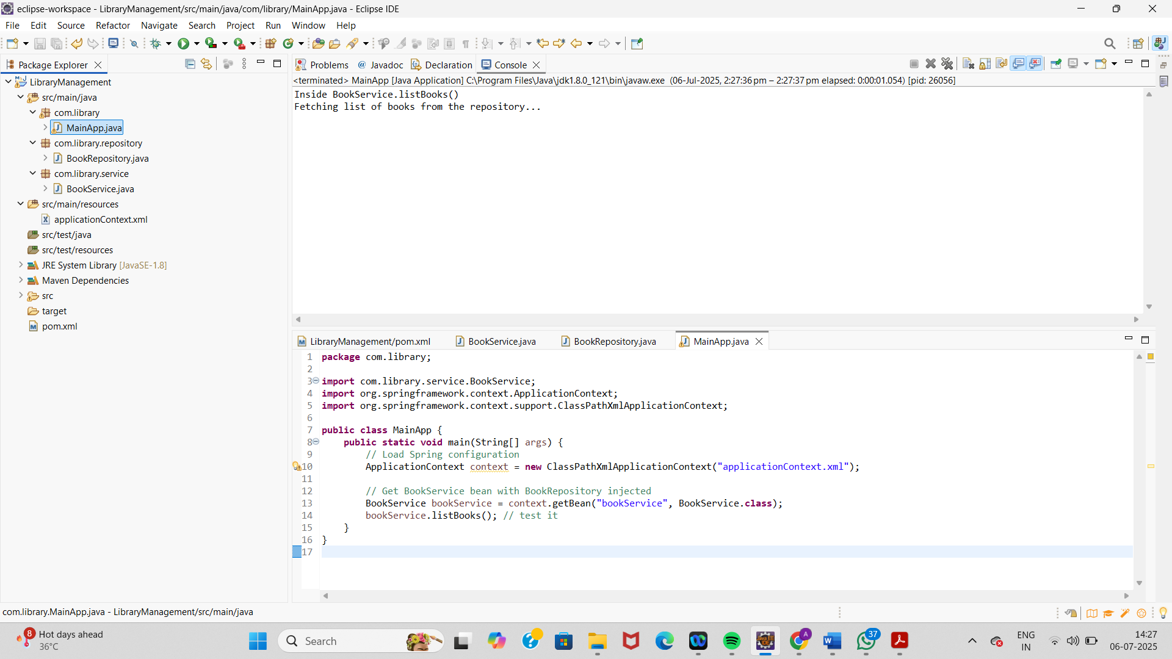

**Exercise 4: Creating and Configuring a Maven Project**

**Scenario:**

You need to set up a new Maven project for the library management application and add Spring dependencies.

**pom.xml**

<project xmlns="http://maven.apache.org/POM/4.0.0"

xmlns:xsi="http://www.w3.org/2001/XMLSchema-instance"

xsi:schemaLocation="http://maven.apache.org/POM/4.0.0

http://maven.apache.org/xsd/maven-4.0.0.xsd">

<modelVersion>4.0.0</modelVersion>

<groupId>com.library</groupId>

<artifactId>LibraryManagement</artifactId>

<version>1.0-SNAPSHOT</version>

<properties>

<maven.compiler.source>1.8</maven.compiler.source>

<maven.compiler.target>1.8</maven.compiler.target>

</properties>

<dependencies>

<!-- Spring Context -->

<dependency>

<groupId>org.springframework</groupId>

<artifactId>spring-context</artifactId>

<version>5.3.33</version>

</dependency>

<!-- Spring AOP -->

<dependency>

<groupId>org.springframework</groupId>

<artifactId>spring-aop</artifactId>

<version>5.3.33</version>

</dependency>

<!-- Spring Web MVC -->

<dependency>

<groupId>org.springframework</groupId>

<artifactId>spring-webmvc</artifactId>

<version>5.3.33</version>

</dependency>

<!-- Servlet API (if needed for WebMVC) -->

<dependency>

<groupId>javax.servlet</groupId>

<artifactId>javax.servlet-api</artifactId>

<version>4.0.1</version>

<scope>provided</scope>

</dependency>

</dependencies>

<build>

<plugins>

<!-- Maven Compiler Plugin -->

<plugin>

<artifactId>maven-compiler-plugin</artifactId>

<version>3.8.1</version>

<configuration>

<source>1.8</source>

<target>1.8</target>

</configuration>

</plugin>

</plugins>

</build>

</project>